ETHICAL HACKING PROJECT

Objective:
Deploy a Linux server on a cloud platform (AWS Free Tier / Oracle Cloud Free Tier / Azure Free Student Credits), secure it using best practices:
Limit SSH access, create IAM-like user roles, apply firewall rules (ufw or security groups), log and audit all access.

Prerequisites - Ubuntu Server 20.04 or 22.04 installed (cloud VM or VMware/VirtualBox)
- SSH client (Linux terminal / macOS Terminal / Windows PowerShell) - Local machine to generate SSH keys.

Commands used:
Initial setup:
sudo apt update && sudo apt upgrade -y
sudo apt install wget curl git -y

Check If SSH server is not running:
sudo apt install openssh-server -y
sudo systemctl enable --now ssh

Server Ip:
hostname -I

SSH from your local machine:
ssh ubuntu@<SERVER_IP>

Create user:
sudo adduser adminuser
sudo mkdir -p /etc/sudoers.d
echo "adminuser ALL=(ALL:ALL) NOPASSWD:ALL" | sudo tee /etc/sudoers.d/adminuser
sudo chmod 440 /etc/sudoers.d/adminuser

Disable root SSH login:
sudo sed -i 's/^#\?PermitRootLogin.*/PermitRootLogin no/' /etc/ssh/sshd_config
sudo systemctl restart ssh

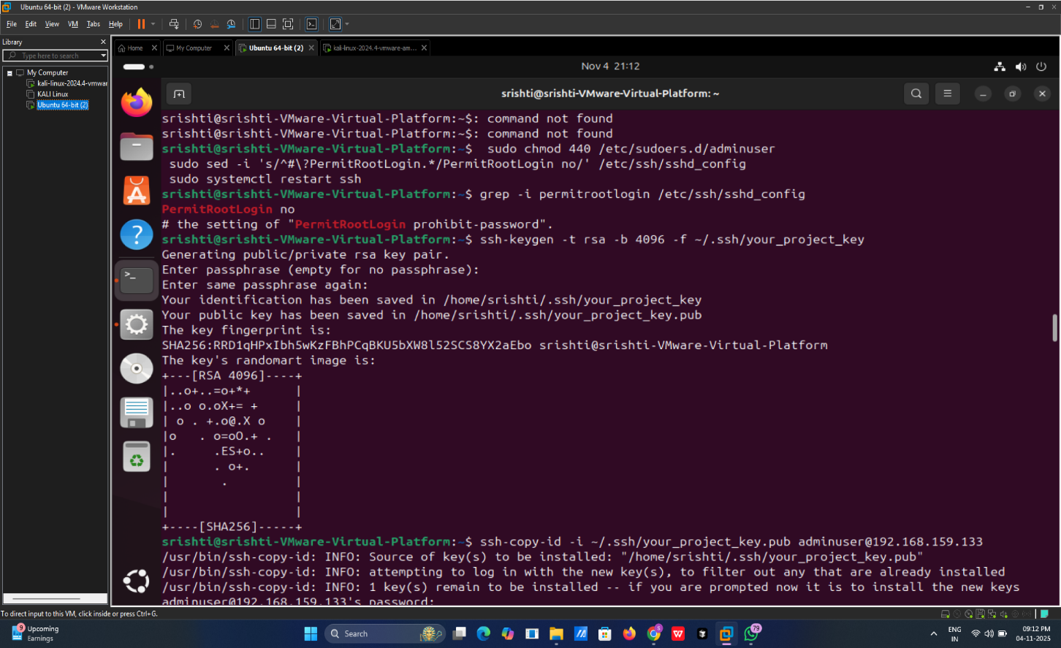
Verify: grep -i permitrootlogin /etc/ssh/sshd_config
Should show: PermitRootLogin no

Enable SSH key authentication:
ssh-keygen -t rsa -b 4096 -f ~/.ssh/your_project_key

Paste public key contents, then:
sudo chown -R adminuser:adminuser /home/adminuser/.ssh
sudo chmod 700 /home/adminuser/.ssh
sudo chmod 600 /home/adminuser/.ssh/authorized_keys

Configure UFW firewall Install & enable UFW:
sudo apt install ufw -y
sudo ufw default deny incoming
sudo ufw default allow outgoing
sudo ufw allow OpenSSH
sudo ufw enable
sudo ufw status verbose

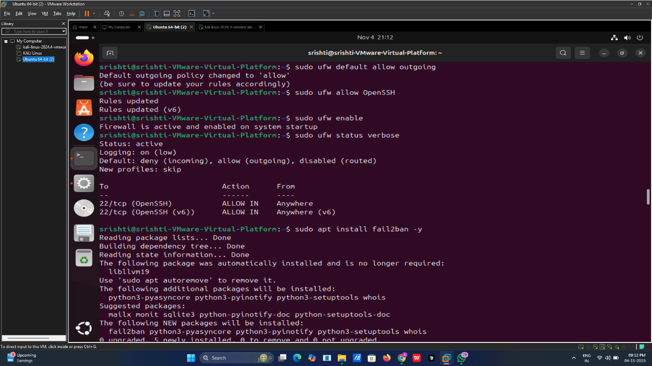

Install & configure fail2ban Install:
sudo apt install fail2ban -y
sudo systemctl enable --now fail2ban

Create a local jail config:
sudo cp /etc/fail2ban/jail.conf /etc/fail2ban/jail.local
sudo bash -c 'cat > /etc/fail2ban/jail.local <<EOF
[sshd]
enabled = true
port = ssh
filter = sshd
logpath = /var/log/auth.log
maxretry = 3
bantime = 3600
EOF'
sudo systemctl restart fail2ban

Check fail2ban status:
sudo fail2ban-client status
sudo fail2ban-client status sshd
sudo tail -n 200 /var/log/fail2ban.log

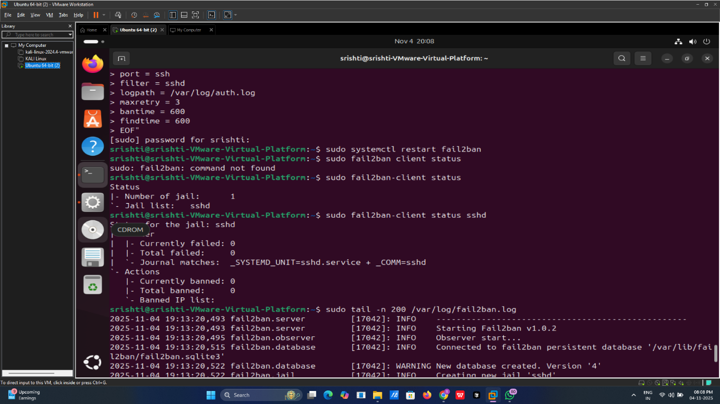

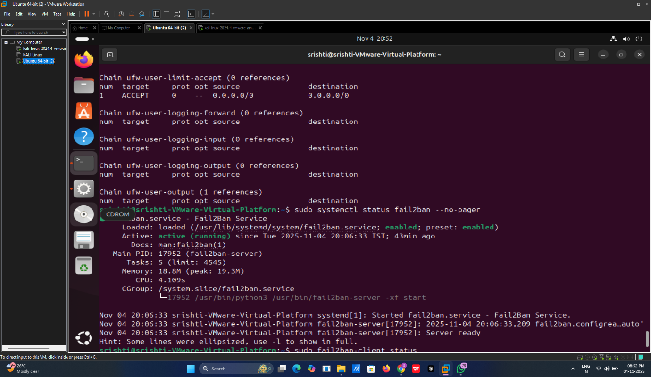

Simulate a ban (from another machine or change IP) by attempting several bad SSH logins and then check `fail2ban-client status sshd`.
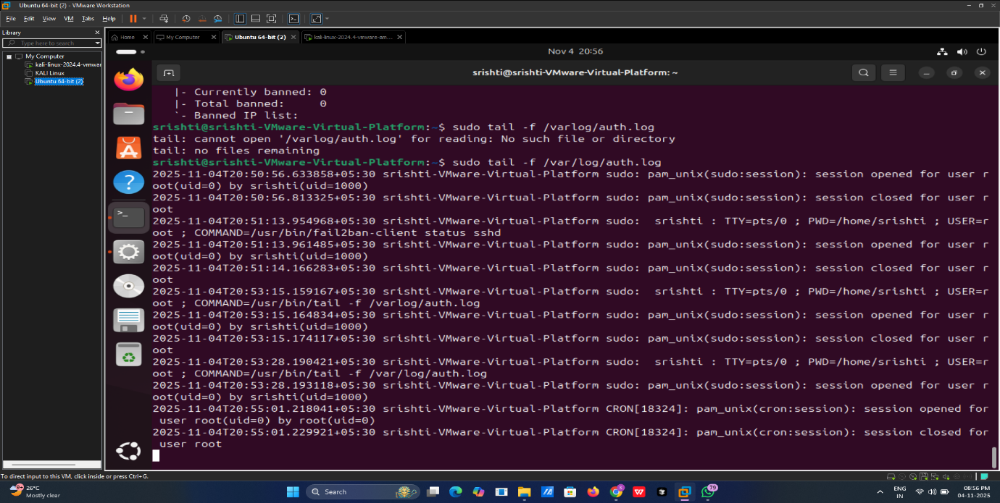

Enable auditing with auditd Install:
sudo apt install auditd audispd-plugins -y
sudo systemctl enable --now auditd
Log all sudo usage (USER_CMD)
sudo auditctl -w /usr/bin/sudo -p x -k sudo_exec

Log authentication events (already logged by PAM in many systems):
sudo ausearch -m USER_LOGIN --start today
sudo ausearch -m USER_CMD --start today

Search audit logs:
sudo ausearch -m USER_LOGIN --raw | aureport --summary
sudo ausearch -m USER_CMD -ts today
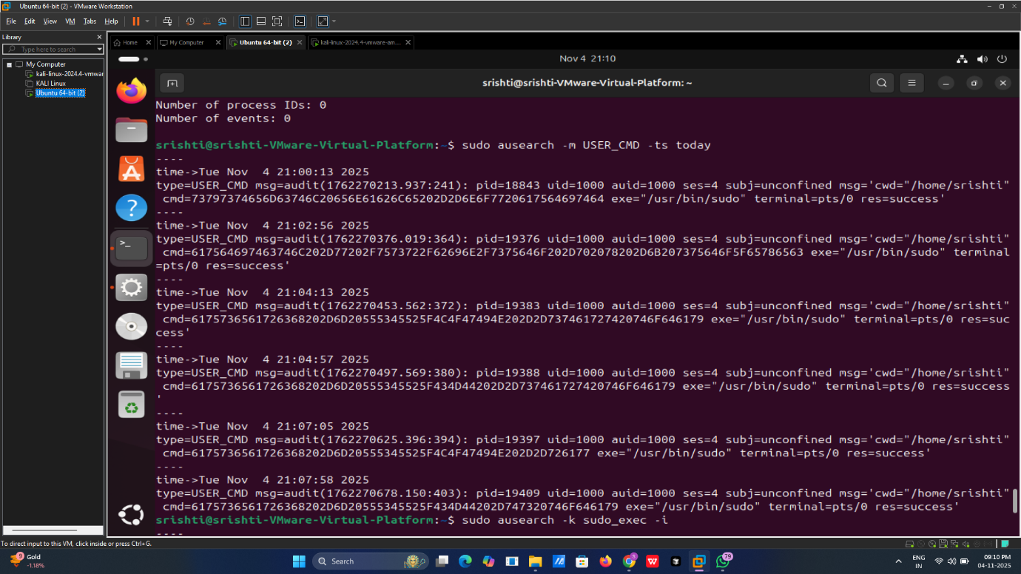

Key learnings:
1). Configured firewall (UFW) to allow only necessary ports.
2). Installed and configured Fail2Ban to block brute-force attacks.
3). Set up SSH key-based authentication and disabled root login.
4). Created limited-privilege (IAM-like) user roles.
5). Applied best practices for server hardening and secure access.

